Del Taco –

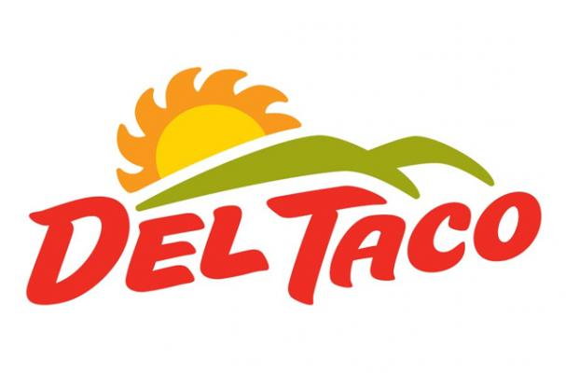

NASKCO rOBOTICS fUNDRAISER

****February 26, 2014**** 3:30PM-9:00PM

2121 12th Avenue Rd, Nampa, ID 83686

|  |  |  |  |  |  |
| --- | --- | --- | --- | --- | --- |
| *The 2012-2013 NASKCO Team* |  | **Support Local Robotics Team** Like Tacos? Like Robots? Then come by Del Taco to support Nampa’s very own robotics team the NASKCOrpions.  NASKCO is a First Robotics Competition team comprised of students from all three of Nampa’s High Schools.   |  |  |  | | --- | --- | --- | |  |  | NASKCO Robotics Team  301 S Happy Valley Rd,  Nampa, ID 83687  http://namparobotics.weebly.com/ | |

*Please print flyer, it is required for our team to receive credit*



Del Taco –

NASKCO rOBOTICS fUNDRAISER

****February 26, 2014**** 3:30PM-9:00PM

2121 12th Avenue Rd, Nampa, ID 83686

|  |  |  |  |  |  |
| --- | --- | --- | --- | --- | --- |
| *The 2012-2013 NASKCO Team* |  | **Support Local Robotics Team** Like Tacos? Like Robots? Then come by Del Taco to support Nampa’s very own robotics team the NASKCOrpions.  NASKCO is a First Robotics Competition team comprised of students from all three of Nampa’s High Schools.   |  |  |  | | --- | --- | --- | |  |  | NASKCO Robotics Team  301 S Happy Valley Rd,  Nampa, ID 83687  http://namparobotics.weebly.com/ | |

*Please print flyer, it is required for our team to receive credit*